

1-800-383-7323 US/CAN



PRODUCT DATASHEET

[www.energizer.com](http://www.energizer.com/)

ENERGIZER 123

(EL123AP)

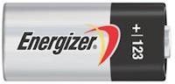

# Industry Standard Dimensions

mm (inches)

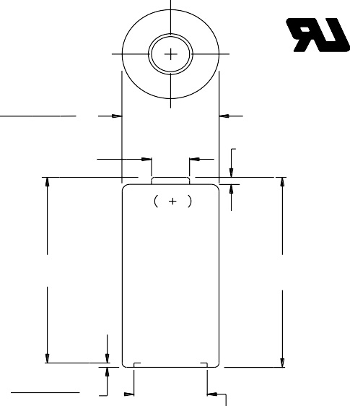

This Battery has Underwriters Laboratories component Recognition

# Specifications

**Classification:** "Lithium"

**Chemical System:** Lithium / Manganese Dioxide (Li/MnO2)

**Designation:** ANSI-5018LC, IEC-CR17345

**Nominal Voltage:** 3.0 Volts

**Storage Temp:** -40°C to 60°C (-40°F to 140°F) **Operating Temp:** -40°C to 60°C (-40°F to 140°F) **Typical Capacity:** 1500 mAh (to 2.0 volts)

(Rated at 100 ohms at 21°C)

**Typical Weight:** 16.5 grams (0.58 oz.)

**Typical Volume:** 7.0 cubic centimeters (0.4 cubic inch) **Max Discharge:** 1500 mA continuous (3500 mA pulse) **Max Rev Current:** 2 uA

**Typical Li Content:** 0.55 grams (0.019 oz.)

**UL Listed:** MH29980

17.00 (0.669)

16.00 (0.630)

9.60 (0.378)

Maximum

1.00 (0.039)

Minimum

33.50 (1.319)

Minimum

34.50 (1.358)

Maximum

# Typical Discharge Characteristics

## Rated Capacity

100 ohms continuous at 21°C

3.5

0.90 (0.035)

0.50 (0.020)

11.00 (0.433)

Minimum

3.0

2.5

**Voltage, CCV**

This battery contains a Positive Temperature Coefficient (PTC) safety device to limit current during short circuit conditions.

# Simulated Application Tests

Typical Use Performance

Cutoff Voltage

Type Drain Load 2.0V (21°C) 1.8V (21°C) 1.55V (21°C)

(time) (mA) (ohms) (hours) (pulses) (pulses)

**Voltage, CCV**

2.0

1.5

3.0

0 20 40 60

## Hours

**Photoflash**

1200 mA (3 sec on / 7 sec off)

**-20°C**

**21°C**

Capacity (continuous)

---

100 58 ---

---

2.5

Photoflash (3 / 27 sec)

900 --- ---

--- 2000

2.0

Photoflash (3 / 7 sec)

1200 ---

--- 1370 ---

1.5

Photoflash (3 / 7 sec)

1800 --- --- 860 ---

1.0

0 300 600 900 1200 1500

## Pulses

**Important Notice**

This datasheet contains typical information specific to products manufactured at the time of its publication.

## ©Energizer Holdings, Inc. - Contents herein do not constitute a warranty.

Form No. EBC - 4204K Page 1 of 1